Opportunity: Choreo Accelerator Programme (in plain English)
Candoco Dance Company is inviting D/deaf, disabled, and neurodivergent choreographers based in the UK to apply for Choreo Accelerator. This is a paid programme to help you develop, create, and tour an original dance performance.
Candoco is a producing dance company. We believe dance is better when difference is celebrated, expanding what dance can be, who makes it, and who experiences it.
You can read more about what Candoco does here, how we make decisions here. Knowing a bit about this will help you with your application.

Key Information:
- Applications open: Thursday 20 August 2026.
- Applications close: Monday 28 September 2026 at 11:59 PM (23.59 BST).
- Who can apply: UK-based choreographers, small companies, or artistic partnerships who identify as D/deaf, disabled, or neurodivergent.
- Location: UK-based.
- Pay: £1,500 for the development stage. The final chosen artist receives a full budget for fees, dancers, creation, and touring.
What is Choreo Accelerator? Candoco’s Choreo Accelerator provides artists with funding, time, and full production support to make a new work and tour it across the UK without having to fundraise yourself.

How the programme works:
- Stage 1 (Commission Readiness Programme): We will select 3 choreographers for a 6-week flexible mentoring programme running in October and November 2026. Each artist will be paid £1,500 for their time.
- Stage 2 (Choreo Accelerator): In late November 2026, the 3 artists will present their ideas. One choreographer will be selected to receive full funding to make and tour their show starting in January 2027. The rest of the cohort will continue to engage with Candoco.
- Stage 3 (Touring): The final show will tour to at least 6 UK venues previewing in late 2027 and touring in 2028.
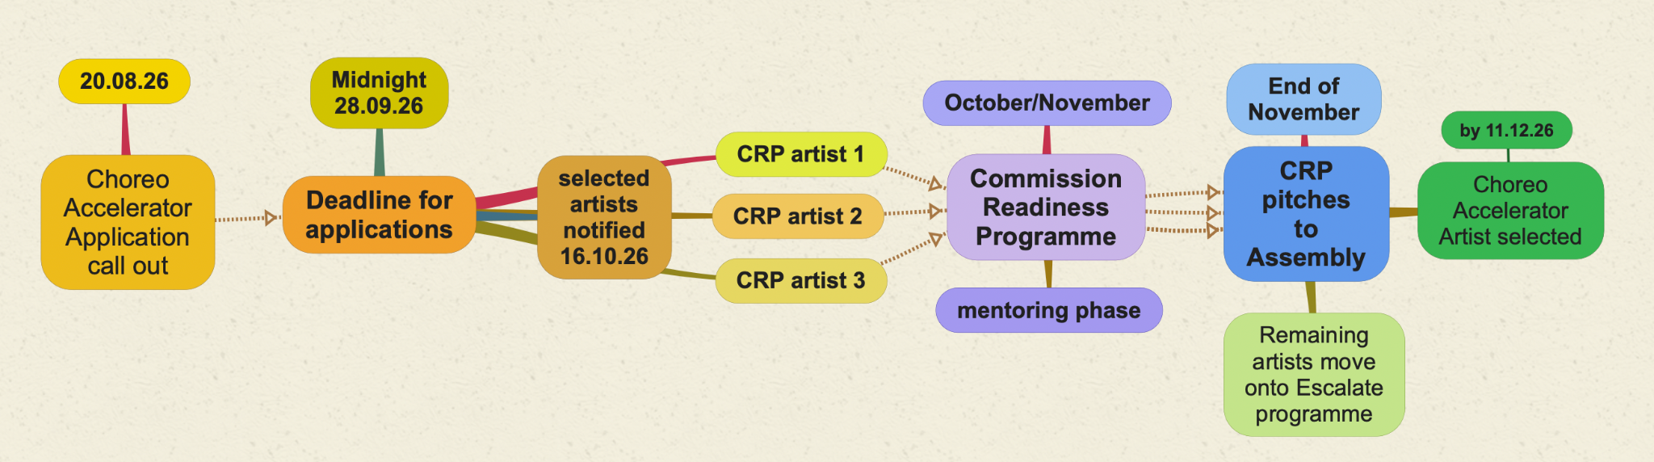

During the 6 weeks of Stage 1 mentoring you will work on your choreography, design and production ideas, and think about which dancers and creative collaborators could help bring your work to life. You will also have support to think about access, production and touring. At the end of it you will create a pitch to present your vision effectively.
You can bring your own mentors or work with Candoco’s pool of experienced mentors, including:
- Benji Reid (benjireid.com)
- Samar Haddad King (ysdt.org)
- Elaine Thomas (amicidance.org)
- Amelia Lander-Carvallo & Quiplash (quiplash.co.uk)
- Janice Parker (janiceparker.co.uk)
- Joe Hornsby (joehornsby.co.uk)
- Sonia Allori (soundandmusic.org)
- Kate Scanlan (scannersinc.com)
- Scott Graham (franticassembly.co.uk)

- If selected you will:
Receive a full commission to cover the costs of making and touring the work. This includes fees, dancers, creative collaborators, producing, production, access, marketing, touring and reporting.
Candoco will support this choreographer managing production, marketing, dancer recruitment, and touring logistics. Access costs are budgeted separately and will not rely solely on Access to Work.

Who should apply?
You should apply if you:
- Are based in the UK. Please note - applicants should have the right to work in the UK.
- Identify as D/deaf, disabled, or neurodivergent (we treat disability as a self-defined identity, please read about our Inclusion Statement here).
- Have created and presented dance work to public audiences before.
- Have an idea for a full-length performance that you want to lead and tour.
- Have experience working with a budget.
You do not need a finished production plan, budget, venue partner, or creative team in place to apply.
Who are we looking for?
We are looking for D/deaf, disabled, and neurodivergent choreographers who have worked on a budget before, who can identify what their creative journey is, and have a clear idea for a new piece of mid-scale touring work.

How to apply
You can apply via online form or other alternative versions. There we ask you to answer short questions about you and your practice.
You can submit your responses through:
- Word document.
- Audio recording.
- Video recording.
- British Sign Language (BSL) video.
- Handwritten or visual notes.
All formats will be evaluated equally. You will not lose marks for spelling, writing style, or grammar. If emailing a Word document, send it to jobs@candoco.co.uk with the subject line: Choreo Accelerator application – [your name].

Access support for applicants
- You can request extra time to complete your application. Extra time must be asked ahead of the deadline.
- You can book a 30-minute session with a writing coach to help you with writing. They cannot write the application for you but help you express your ideas in clear and concise language.
- This call-out is available in Plain Text, Large Print, Audio, and BSL.
For access support or alternative formats, email info@candoco.co.uk.
Questions?
- General questions: Contact Nick Galak-Anderson and Emma Wee at nick@candoco.co.uk or emma@candoco.co.uk.
- Application or access support: Email jobs@candoco.co.uk.
Important dates:
- 20 August 2026: Applications open.
- 28 September 2026 (11:59 PM): Application deadline.
- 7–16 October 2026: Applicants notified of results.
- October – November 2026: Mentoring period for 3 selected artists.
- By 11 December 2026: Final choreographer selected.
- January 2027 onwards: Work creation begins.
- Autumn 2027: Preview.

